Supervised Learning
Decision Tree –
RMSE- Reduce Root Mean Square error (Reduce Error)
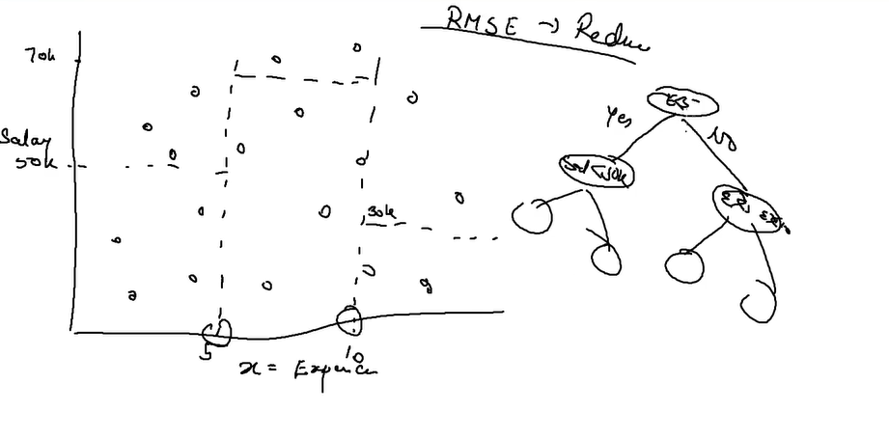

If a new record arrives checks, where it belongs (group) , assign the average of that group to new record

Import all the packages

import numpy as np
import pandas as pd
import matplotlib.pyplot as plt
import os
import seaborn as sns
from sklearn.metrics import r2_score

Import Data Set

os.chdir('C:\\Noble\\Training\\Top Mentor\\Training\\Data Set\\')
df1= pd.read_csv('Position Salary .csv')
print (df1)

Split Data into X and Y

x= df1.iloc[:,1:2].values
print (x)

Display Y

y= df1.iloc[:,2].values
print (y)

Plot the Graph with X and Y

plt.plot(x,y)
plt.show()

Create Linear Regression First
from sklearn.linear_model import LinearRegression
reg = LinearRegression()
reg.fit(x,y)
print (reg)

Linear regression Prediction

lr_pred = reg.predict (x)
print (lr_pred)

Linear regression Prediction Result

lr_result = pd.concat ([df1, pd.DataFrame(lr_pred,columns = ['Prediction'])],axis = 1 )
lr_result['Difference'] = lr_result['Salary'] - lr_result['Prediction']
print (lr_result)

Display Accuracy
accuracy = r2_score (y,lr_pred)
print (accuracy)

Plot Graph
plt.plot (x,y)
plt.plot (x,lr_pred)
plt.show()

Create the Model – Decision Tree
from sklearn.tree import DecisionTreeRegressor
dt =DecisionTreeRegressor()
dt.fit(x,y)
print (dt)

Predicted Values

y_pred = dt.predict(x)
print (y_pred)

R2_Score – Accuracy

accuracy = r2_score(y,y_pred)
print (accuracy)

Display Complete Data
result = pd.concat ([df1, pd.DataFrame(y_pred,columns = ['Prediction'])],axis = 1 )
print (result)

Plot Result Graph
Ravel is used to convert array from 2-dimensional array to 1-dimensional array , arrange () works only on 1-dimensional array

flat_x =x.ravel()
x_grid = np.arange(min(flat_x),max(flat_x),0.1)
x_grid = x_grid.reshape((len(x_grid),1))
plt.scatter(x,y,color= 'r')
plt.plot(x_grid, dt.predict(x_grid))
plt.show()
Plot the Regression and Decision Tree results

flat_x =x.ravel()
x_grid = np.arange(min(flat_x ),max(flat_x ),0.1)
x_grid = x_grid.reshape((len(x_grid),1))
plt.scatter(x,y,color= 'r')
plt.plot(x_grid, dt.predict(x_grid))
plt.plot(x_grid, reg.predict(x_grid))
plt.show()

Create a Model with min sample split = 8

from sklearn.tree import DecisionTreeRegressor
split_dt =DecisionTreeRegressor(min_samples_split=8)
split_dt .fit(x,y)
print (split_dt )

Display Prediction
split_pred = split_dt.predict (x)
print (split_pred)

Create a Model with min sample split = 6

from sklearn.tree import DecisionTreeRegressor
split_dt6 =DecisionTreeRegressor(min_samples_split=6)
split_dt6 .fit(x,y)
print (split_dt6 )

Display Prediction

split_pred6 = split_dt6.predict (x)
print (split_pred6)

Plot Decision Tree and Decision Tree with Split = 6 result

flat_x =x.ravel()
x_grid = np.arange(min(flat_x ),max(flat_x ),0.1)
x_grid = x_grid.reshape((len(x_grid),1))
plt.scatter(x,y,color= 'r')
plt.plot(x_grid, dt.predict(x_grid))
plt.plot(x_grid, split_dt6.predict(x_grid))
plt.show()

.

Create the Model – Decision Tree

from sklearn.tree import DecisionTreeRegressor
dt =DecisionTreeRegressor()
dt.fit(x,y)
print (dt)

Prediction for New Data

arr1 = np.array([10,12])
print (arr1)
arr1= arr1.reshape (2,1)
print (type(arr1))
y_pred= dt.predict(arr1)
print ('Prediction')
print (arr1,y_pred )

Random Forest – Multiple times decision tree and takes the average

Algorithm

from sklearn.ensemble import RandomForestRegressor
rf= RandomForestRegressor (n_estimators =5)
rf.fit(x,y)
print (rf)

Predicted Values

y_pred = rf.predict(x)
print (y_pred)

R2_Score – Accuracy
accuracy = r2_score(y,y_pred)
print (accuracy)

Display Complete Data

result = pd.concat ([df1, pd.DataFrame(y_pred,columns = ['Prediction'])],axis = 1 )
result['Difference'] = result['Salary'] - result['Prediction']
print (result)

Create the graph

flat_x =x.ravel()
x_grid = np.arange(min(flat_x ),max(flat_x ),0.1)
x_grid = x_grid.reshape((len(x_grid),1))
plt.scatter(x,y,color= 'r')
plt.plot(x_grid, rf.predict(x_grid))
plt.show()

Predictions

arr1 = np.array([10,12])
print (arr1)
arr1= arr1.reshape (2,1)
print (type(arr1))
y_pred= rf.predict(arr1)
print (arr1,y_pred )

